Lab 5
source code at:
https://github.com/telenovelachuan/data_science/blob/master/EECS_738_machine_learning/lab5/Lab5.ipynb

1. Use a similar baseline model as in Lab 3 with architecture 64, 64, 64, 10. Turn it into Keras functional API model:
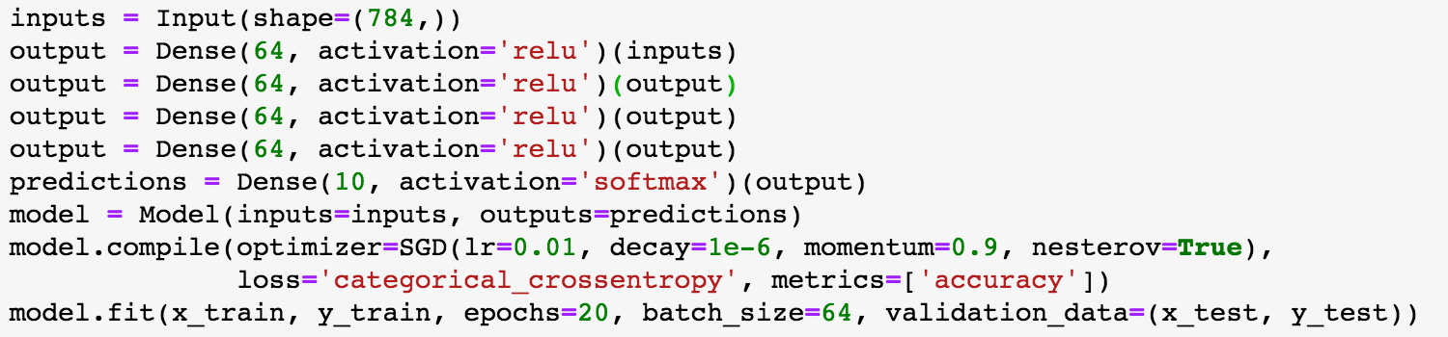
This baseline model gets an accuracy of .9760 after 20 epochs training with batch size 64, which takes 104s.

2. Compare this baseline model with the given ResNet with 3 residual blocks and 2 skips. The ResNet looks like:

This ResNet reaches an accuracy of .9964 after 20 epochs’ training, consuming 450s. The accuracy increased by 2.1% but training time increased by 332%. Basically ResNet works by adding the input with some residual blocks, so that the mapping we are originally trying to train between input and output, denoted by F(x), changes to F(x) + x. And the latter one often fits the target better, or at least not worse. This is also a good solution for the gradient vanishing problem, since now the layers far away from the output could get its gradient through the skip connections.

3. To implement a deeper ResNet, a function was created to customize any number of layers and skips. The model architecture looks like below:
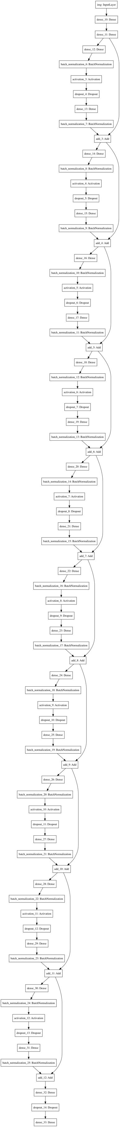
The 10-layer ResNet reaches an accuracy of .9958(0.06% lower), but it took 938s(108% higher). For this problem, given this magnitude of accuracy difference, the 3-layer net will be preferred since it halved the training time.

4. Both the 1-skip and the 3-skip ResNet were implemented, and below are their comparison in summary.
 | Accuracy | Training time(s)
1-skip ResNet | .9961 | 279
2-skip ResNet | .9964 | 450
3-skip ResNet | .9959 | 772

The 3-skip ResNet uses 177% more time to train than the 1-skip ResNet, since there’re more layers in a residual block, more weights need to be updated in both forward and backward propagation. While consuming more neurons and time to train, the 3-skip net does not outperform the 1-skip one in this dataset. I guess it’s due to the characteristic of the MNIST dataset. More skip connections will provide more magic in some more complicated scenarios.

5. Finally welcome to the CIFAR-10 dataset. First apply a baseline-like model for testing. The comparison is summarized below.
 | Accuracy | Training time(s)
MNIST | .9760 | 104
CIFAR-10 | .4905 | 315

The baseline model barely works for the CIFAR dataset. Since the mapping between input and output goes far more complicated. Simply stacking dense layers can no longer learn the patterns existing between the target categories and the input pixels thoroughly. Also, CIFAR-10 almost triples the training time, since image data increase to 3 channels.

6. Let’s apply a shallow ResNet(3 blocks) onto the CIFAR dataset. The model outputs an accuracy of .9101. Detailed comparison are as below.
 | Accuracy | Training time(s)
ResNet for MNIST | .9964 | 450
baseline for CIFAR | .4905 | 315
ResNet for CIFAR | .9101 | 725

We got amazing performance boost! The ResNet drastically outperforms the baseline by using skip connections and residual blocks with batch normalization. The skip connections added with residual blocks makes a closer fit of the training data by enabling f(x) + x. That’s quite a different idea than a CNN, albeit both works for image recognition.

7. It’s always fascinating to have some freedom playing with parameters and customize a best model. Here, the parameters being tuned include: residual block depth, number of skips, learning rate on optimizer(and even the entire optimizer), number of neurons per layer, dropout rate, and batch size. Before deep diving into parameter tuning, convolutional layers are also tried (not in residual blocks but after all blocks) but they didn’t seem to help. So it turned out to be a sheer observation on the performance change driven by tinkering standard ResNet architecture.
After tons of tuning, the best model tuned for the dataset contains the below parameters.
- block depth: 10
- skips: 3
- learning rate: 1e-3
- dropout rate: 0.1
- neurons per layer: 200s

According to the empirical experience during parameter tuning, increasing residual block depth a little bit will help with accuracy in the CIFAR dataset. Deeper block depth enables more capability in extracting & understanding regional information in the input image. Also the skips matter as well. Practically, setting skips too low or too high will make the performance decline. It’s quite possible that increasing the block skips involves deeper layers per residual block, where gradient vanishing would occur for the first few layers inside the block.

8. The residua network differs from the baseline model mainly by using skip connections. So that the input x would be added up with the block output to model the mapping. As discussed above, changing the mapping from F(x) to F(x) + x enables stronger capability in fitting the training data than F(x) itself, since F(x) could be acting as identity mapping to ensure it works at least no worse than the baseline.
Besides, theoretically, adding the input with block output would help the gradient descent process to retain larger gradient from subsequent layers for the input layer, thus alleviating the gradient vanishing problem for deeper networks.
To generally improve the architecture for future models, I think it should involve consideration on deeper layers to enable representation as well as computational viability, which is a trade-off in most cases. Adopting more layers would be a general trend for comprehension related tasks such as image recognition, while the architecture should optimize toward pruning connections for gradient passing as well as for computation efficiency. For example, partially connected layers such as cov2d and pooling could be considered inside residual blocks.

9. The group project deals with a housing price dataset that contains a dozen of features depicting samples of housing info and their prices in Beijing. So looking from the dataset itself, it is not a typical scenario where ResNet could sufficiently help. However, the idea of skip connections and identity function would be a tuning option for neural network architecture in predictive modeling if it does not fit the data well.

